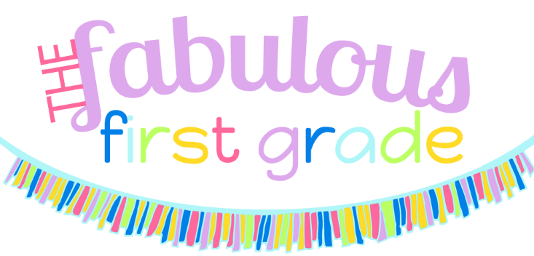

**Supply List**

**Campus Community School 2019-2020**

Individual Supplies (Please label with child’s name):

* 1 Backpack (small, no wheels please)
* Lunch Box and freezer pack
  + (lunches will be kept in the classroom, no refrigeration available)
* 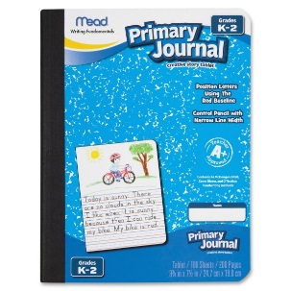**2** **PRIMARY** Composition notebook (1 for writing, 1 for science/social studies)

The Community Supplies below will be shared by the class. This allows us to replenish supplies as needed and teach children to work together as a community. You **do not** need to label them with your child’s name.

3 boxes of tissues

 2 box crayons

1 package of markers

1 package of EXPO markers

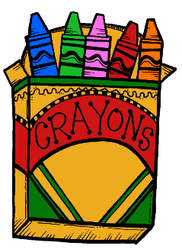 1 box colored pencils

1 package of pencils

1 package of pink erasers

1 package of glue sticks

1 packages of baby wipes (**GIRLS)**

1 package Lysol type cleaning wipes **(BOYS)**

1 roll of paper towels

1 box plastic baggies (**GIRLS** – quart size; **BOYS** – gallon size)

**\*\*Some community items such as art supplies or cleaning supplies may need to be replenished later in the year.\*\***

