Campus Community School
Second Grade Supply List
Individual student supplies
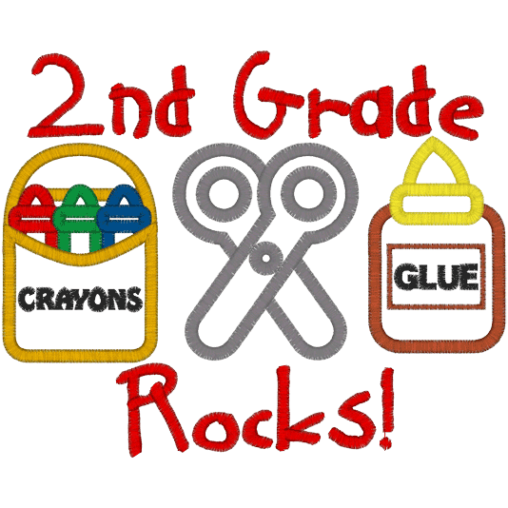
3 wide-ruled single subject spiral-bound notebooks
$6 for Scholastic News (purchased through the school)
$6 for school planner (purchased through the school)
Shared class supplies
1 BLUE folder with pockets
1 GREEN folder with pockets
4-6 glue sticks
3 boxes of tissues
2-24 pack of pencils
2 boxes of crayons
4 pink erasers
6-8 Expo markers

*Students should bring their supplies the first day of school or during the Meet and Greet prior to the school year starting.

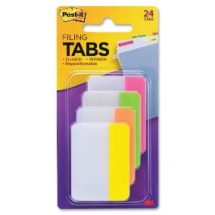
1 roll of paper towels
2 containers of Clorox wipes
1 pack of post it notes
1 pack of Post it Filing tabs
1 composition notebook (Spanish)
Girls (to be shared with the class)
1 box of sandwich Ziploc bags
1 pack of construction paper
Boys (to be shared with the class)
1 pack of highlighters
1 pack of lined wide ruled paper

