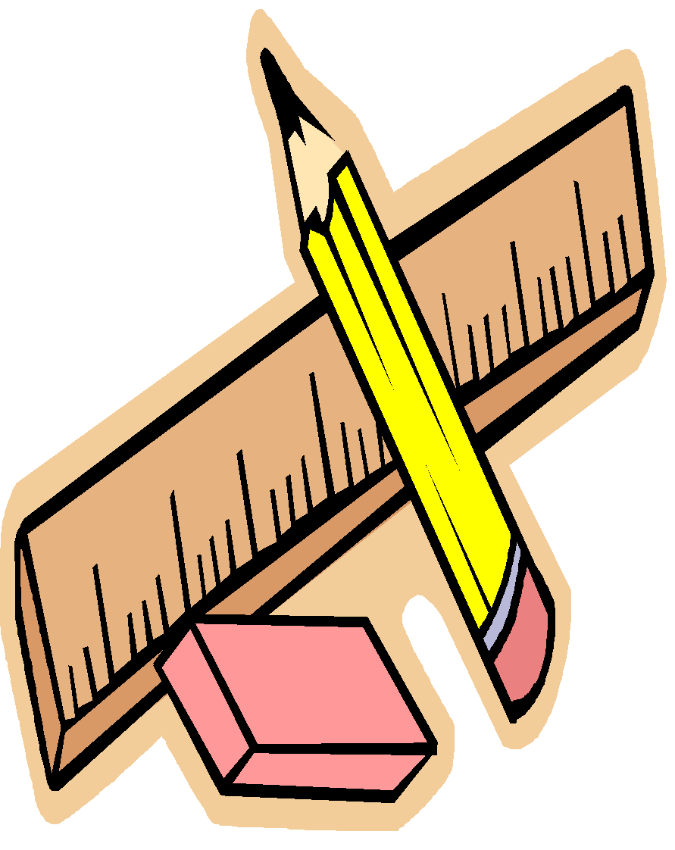
3rd Grade Supply List

Mrs. Thompson
Mrs. Harklerode

Personal Supplies (please label with student’s name):
- Small Book Bag (no wheels please, due to the limited space)
- Water Bottle
- 1 Composition Notebook
Classroom Supplies (please do not label with student’s name):
- 1 Box of Markers
- 1 Box Colored Pencils
- 3 Total Glue Sticks
- 3 Packs of 12 Pencils (yellow pencils, pre sharpened preferred)
- 3 Chunk Erasers
- 1 Box of Tissues
- 1 Pack of Thin Expo Dry Erase Markers
- 1 Box of Ziploc Plastic Bags (girls bring quart, boys bring gallon)
- 2 rolls of Paper Towels
- 2 containers of Clorox Wipes

These items may need to be replenished throughout the year, so you may want to buy extra supplies when they’re on sale.
Thank you in advance!

