Accessing the Lunch Menu

- First using the “Breakfast & Lunch” Link shown below navigate to the http://preferredmealsmenu.com/ website.
- When you are at the Preferred Meals website site you will need to search by state and school under the “Find Your School” section. You can do this by Clicking the Down Arrow next to select state (Example A). And then selecting “DE” as shown below (Example B).
Example A: Example B:
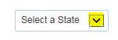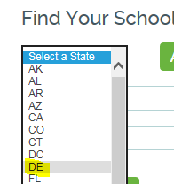

- Then for the “Select a District or Charter Organization” you again will use the Down Arrow
(Example C.) And select “Campus Community School” as shown (Example D.)
Example C:
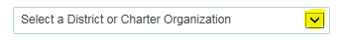
Example D:
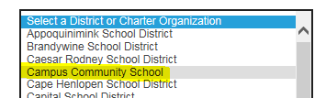

- After that you will need to select an option for the “Select A School” section. Again using the dropdown (Example E.) you will need to select “Campus Community Charter School” (Example F.).
Example E:
Example D:
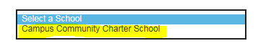

- Finally you can now click the “Display Menus” Button (Example G.) and this will take you to the Menu (Example H.)
Example G:
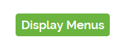
Example H:

