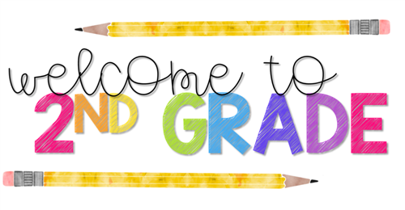

Campus Community School
Supply List
1-Wide rule Spiral notebook
5- Composition books
We do ask that student supplies are not labeled, we will divide supplies amongest students for their individual use as needed. Supplies can be brought in during Meet and Greet!
2- Pocket Folders
1-Pack of pencils
1-Box of markers
1-Box of Colored Pencils
2-Boxes of crayons
2-Glue sticks
2-Pink erasers
1-Pack of Wide rule loose leaf paper
4-Expo markers
3-Boxes of Tissues
1-Roll of Paper Towels
1-Pack Ziploc bags
1-Pack of highlighters
1-Personal hand sanitizer
1-Plastic water bottle
1-Personal pencil box

