Campus Community School
Second Grade Supply List 2022-2023
Mrs. C’s Class

Individual student supplies (Please label with child’s name)
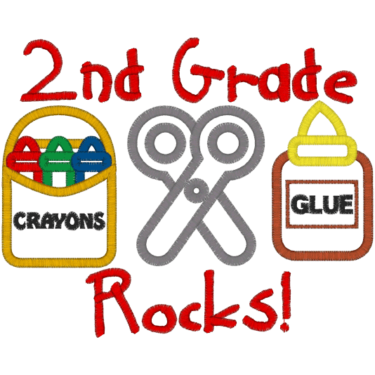
5 composition note books
1 plastic water bottle
1 Personal hand sanitizer
1 pencil box
1 box of mask (optional)

Shared class supplies
1 folders with pockets
1 pack of highlighter
3 boxes of tissues
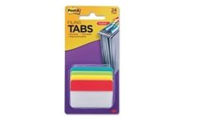
2 pink erasers
1 pack of post-it notes
1 roll of paper towel
1 container of Clorox disinfecting wipes

*Students should bring their supplies on the first day of school. They may also be dropped off during the Meet and Greet prior to the school year starting.

